BÀI THỰC HÀNH CHƯƠNG 3_1
Họ tên: | Đổng Trung Đức
Mã sinh viên: | 20222877
Lớp: | DCCNTT 13.10.16

Bài 01:
Chạy lệnh: php artisan make:model Employee -a
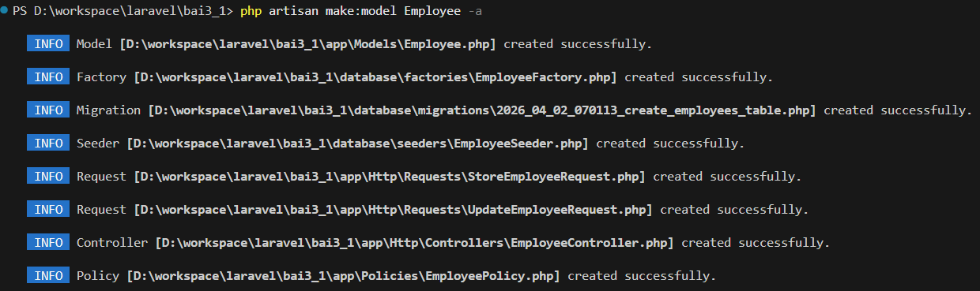

Sửa file: app/Models/Employee.php
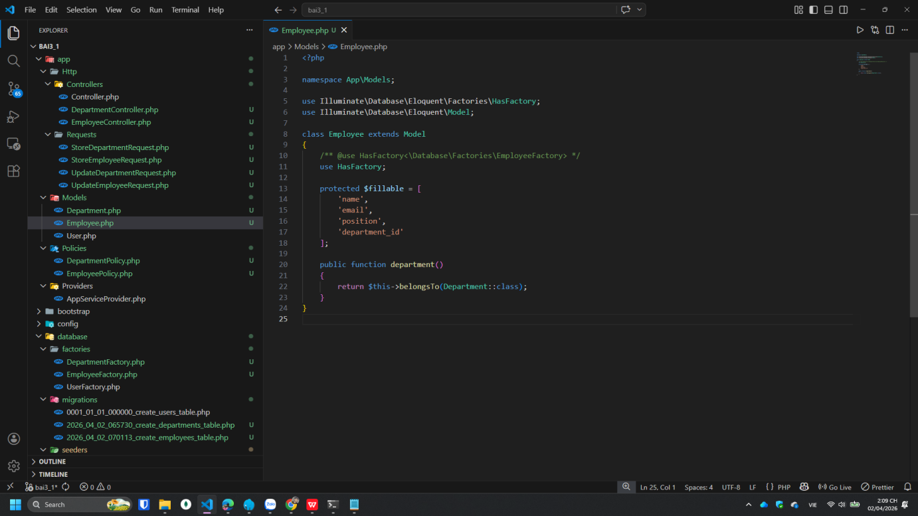

Bài 02:
Chạy lệnh: php artisan make:model Department -a
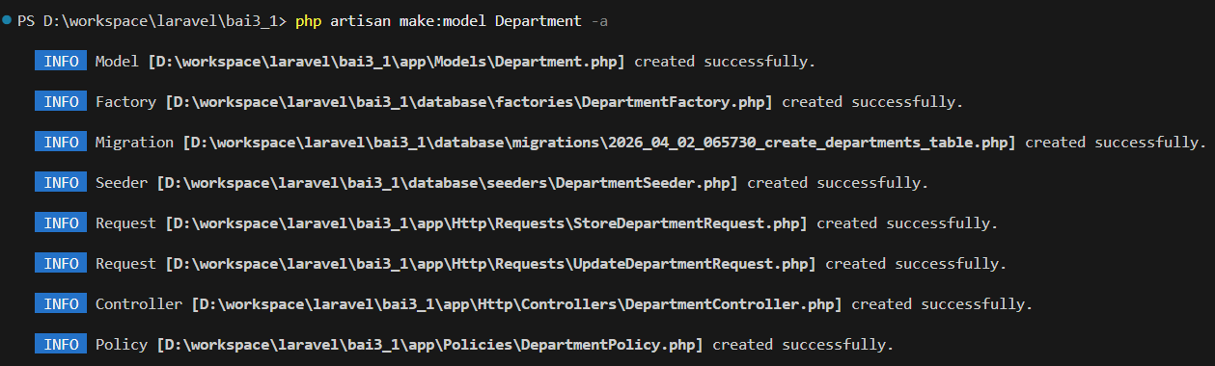

Sửa file: database/migrations/2026_04_02_065730_create_departments_table.php
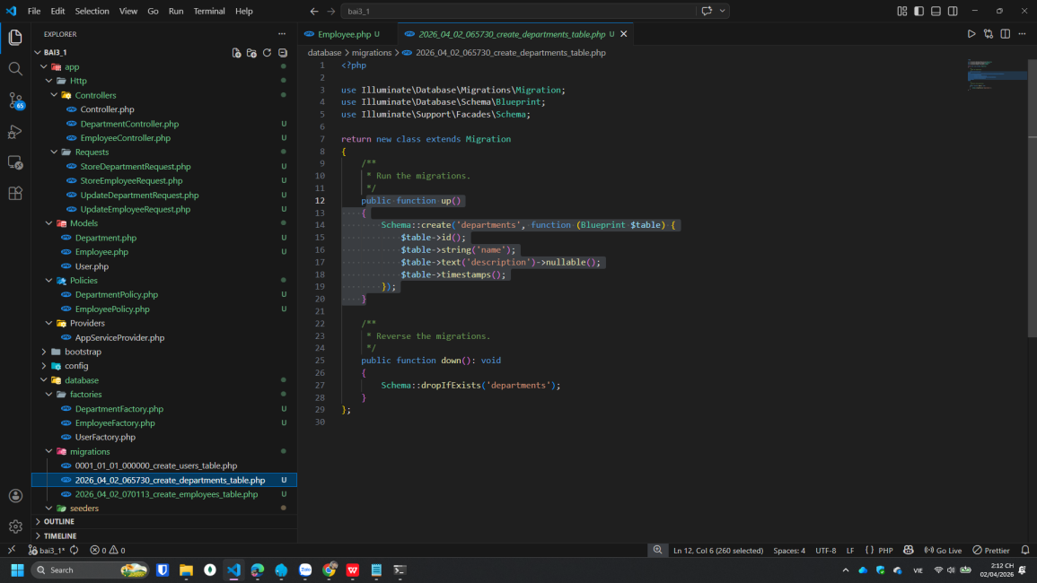

Chạy lệnh: php artisan migrate:fresh
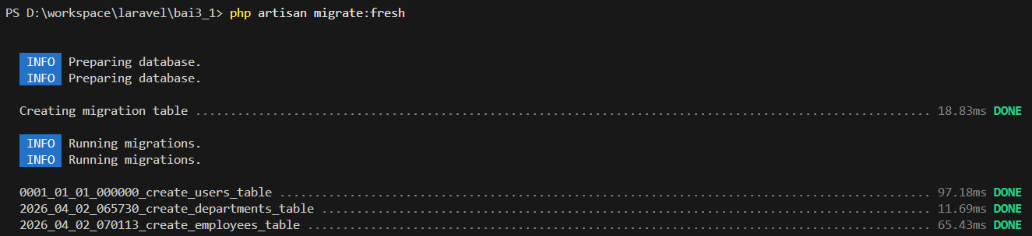

Bài 03:
Sửa file: app/Http/Controllers/EmployeeController.php
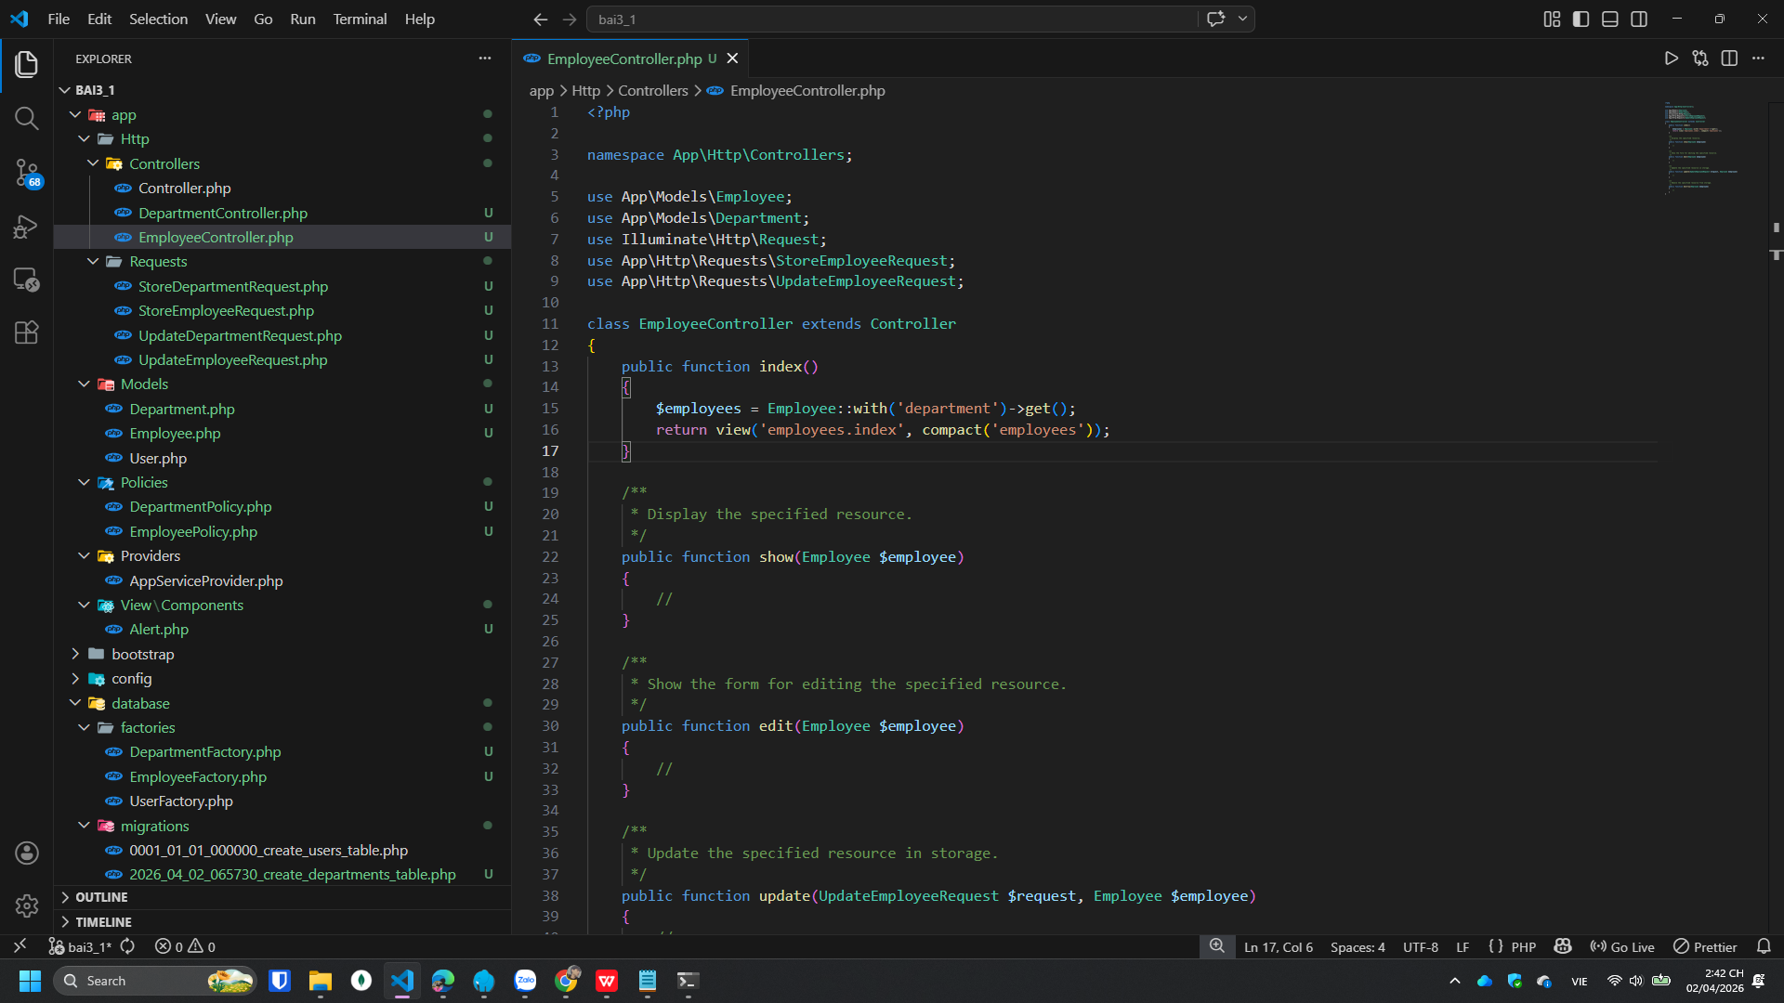

Bài 04:
Tạo file resources/views/employees/index.blade.php
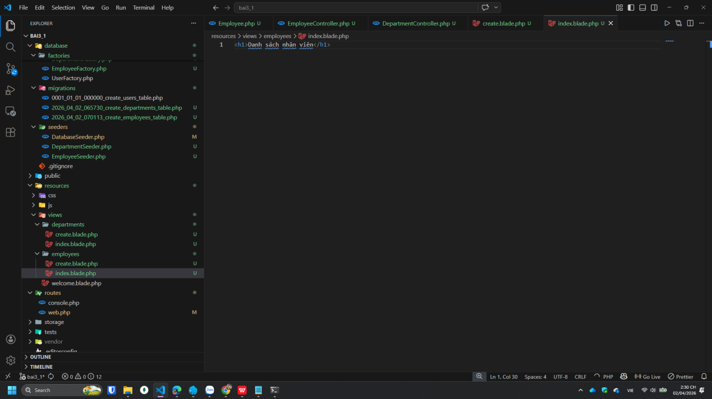

Bài 05:
Sửa file resources/views/employees/index.blade.php
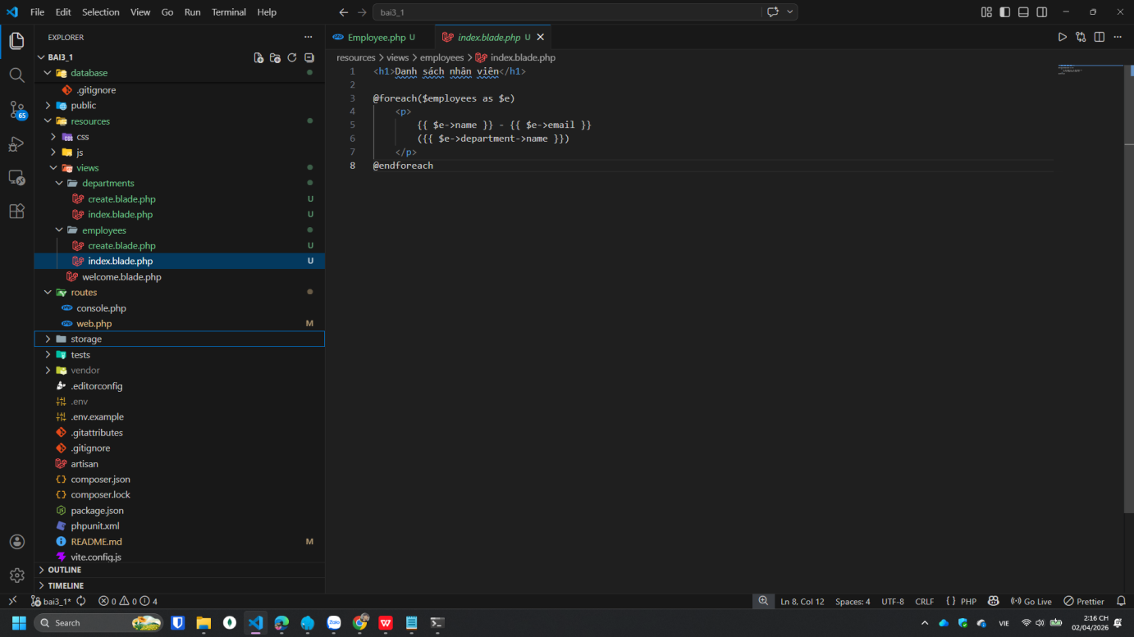

Bài 06:
Sửa file resources/views/employees/index.blade.php
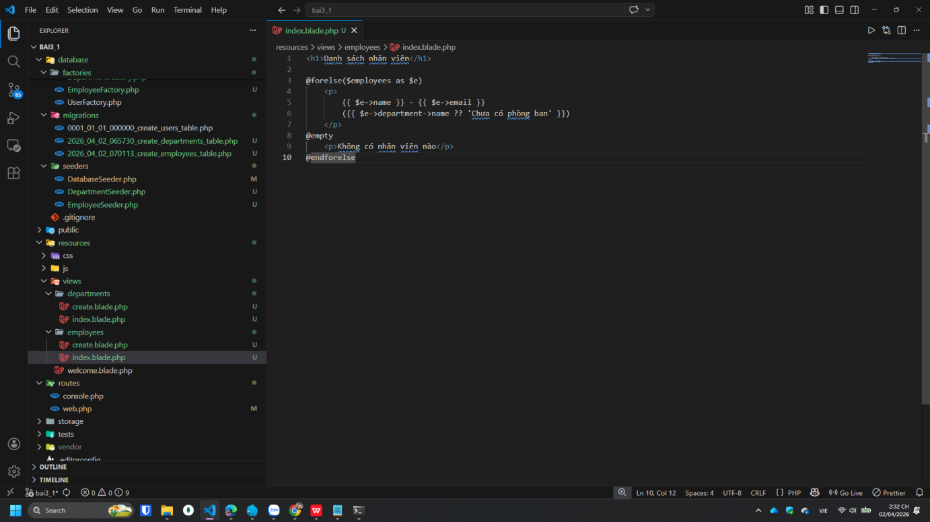

Bài 07:
Tạo file resources/views/layouts/master.blade.php
Và sửa file resources/views/employees/index.blade.php
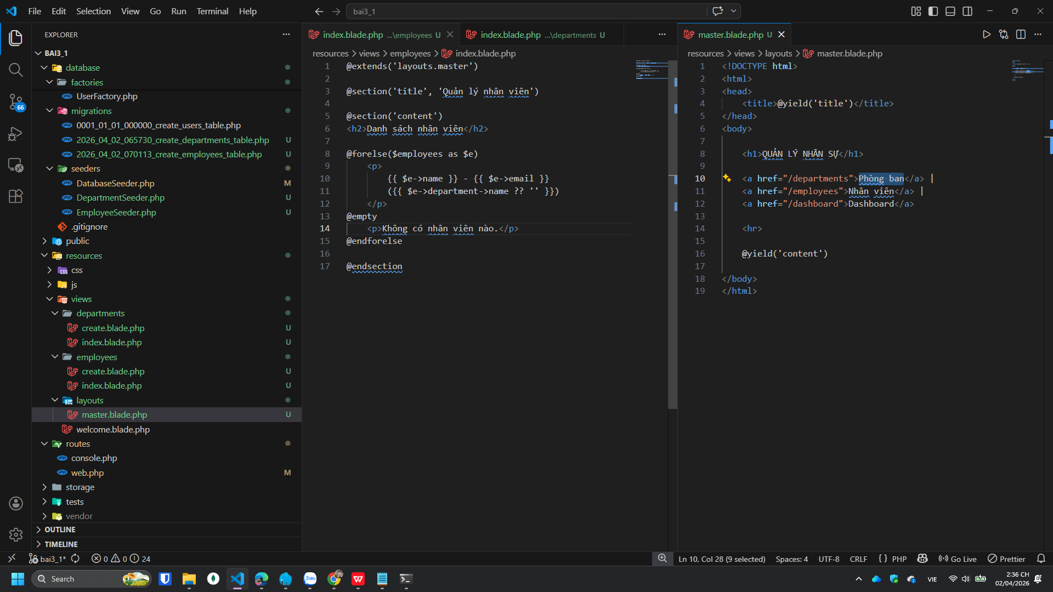

Bài 08:
Chạy lệnh: php artisan make:component Alert
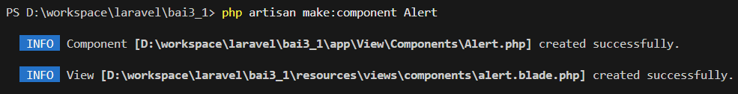

Bài 09:
Sửa route: routes/web.php
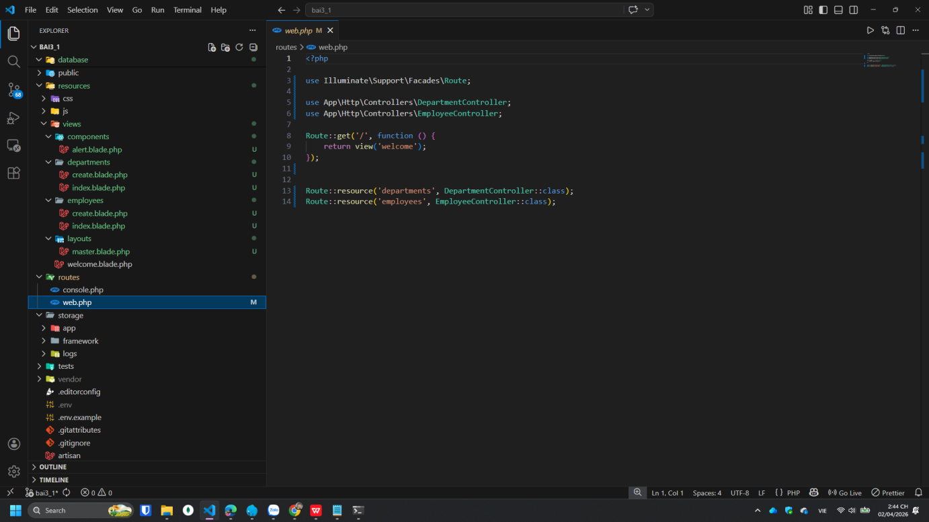

Sửa file: app/Http/Controllers/EmployeeController.php
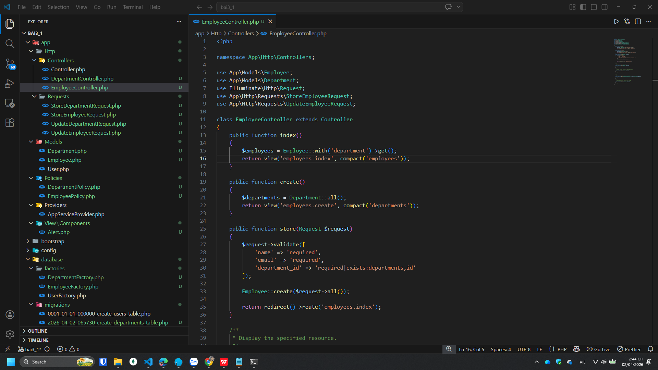

Bài 10:
Tạo file resources/views/employees/create.blade.php
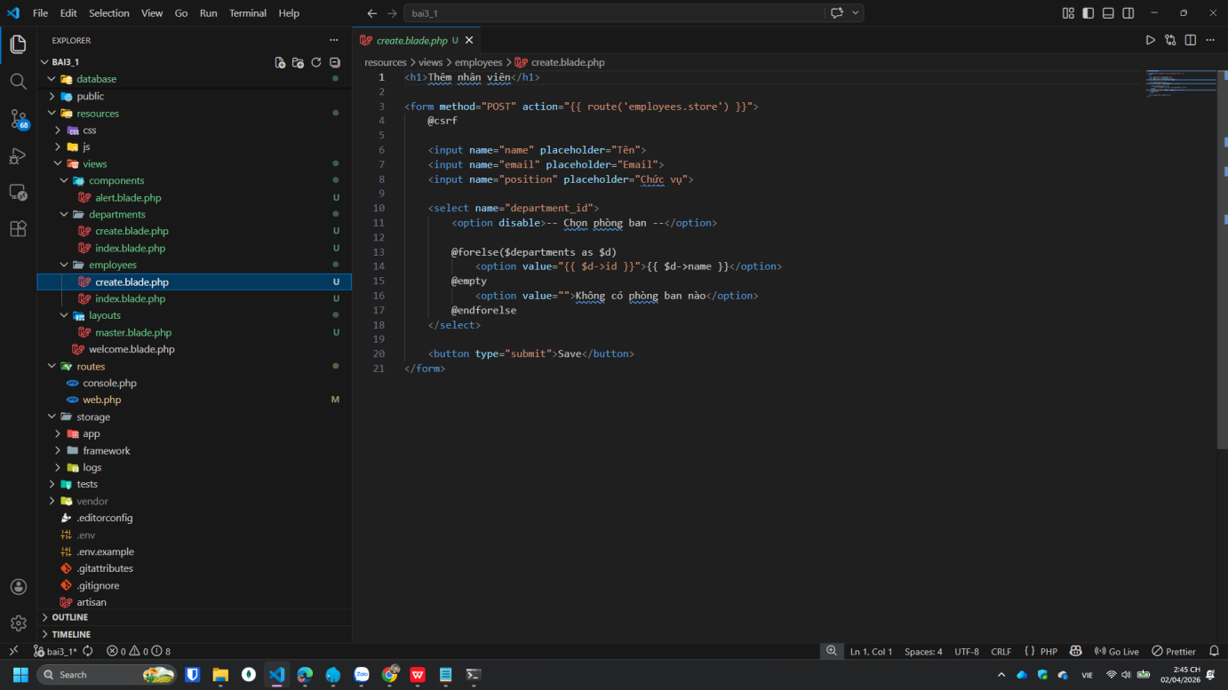

Bài 12:
Tạo file resources/views/employees/dashboard.blade.php
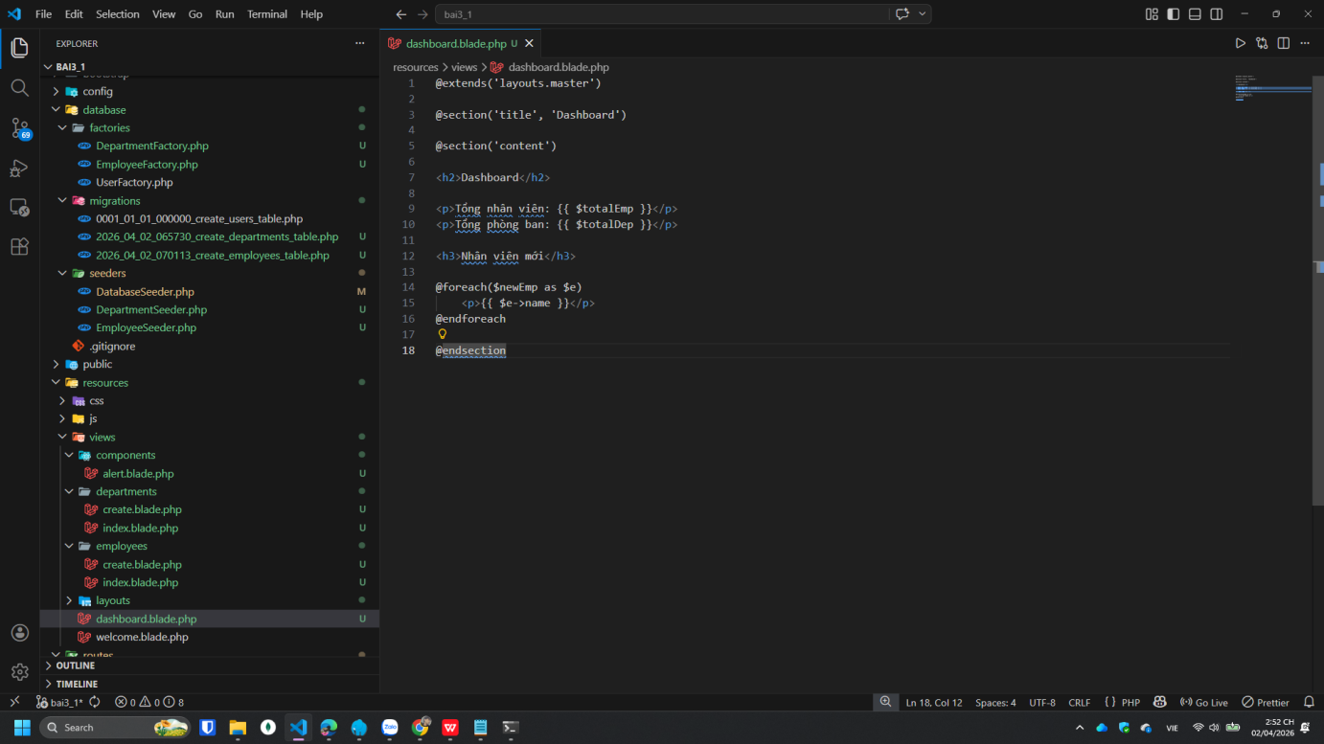

Bài 14:
http://127.0.0.1:8000/departments/create
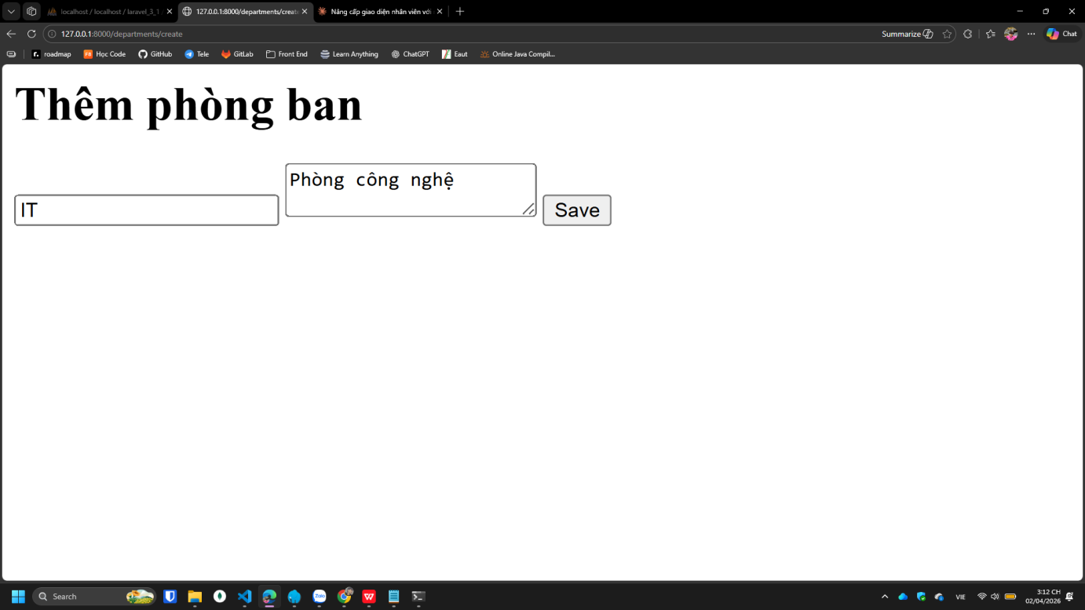

http://127.0.0.1:8000/departments
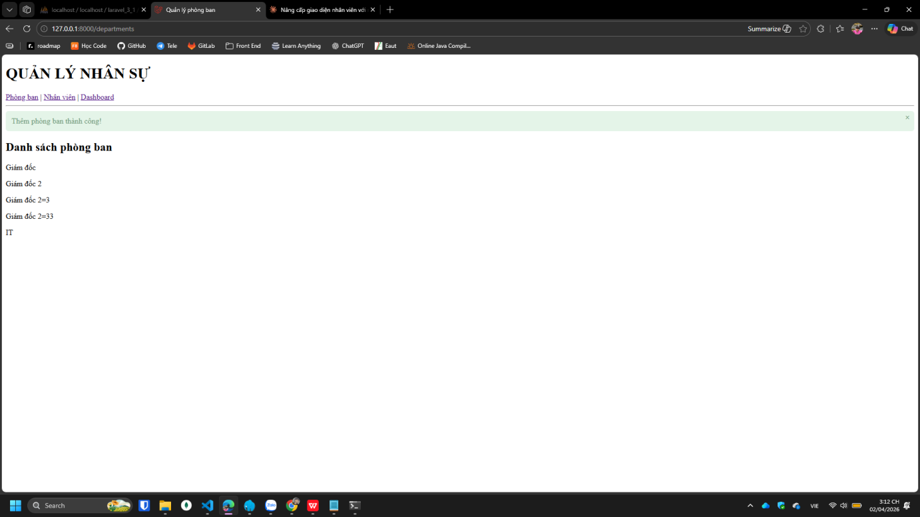

http://127.0.0.1:8000/employees
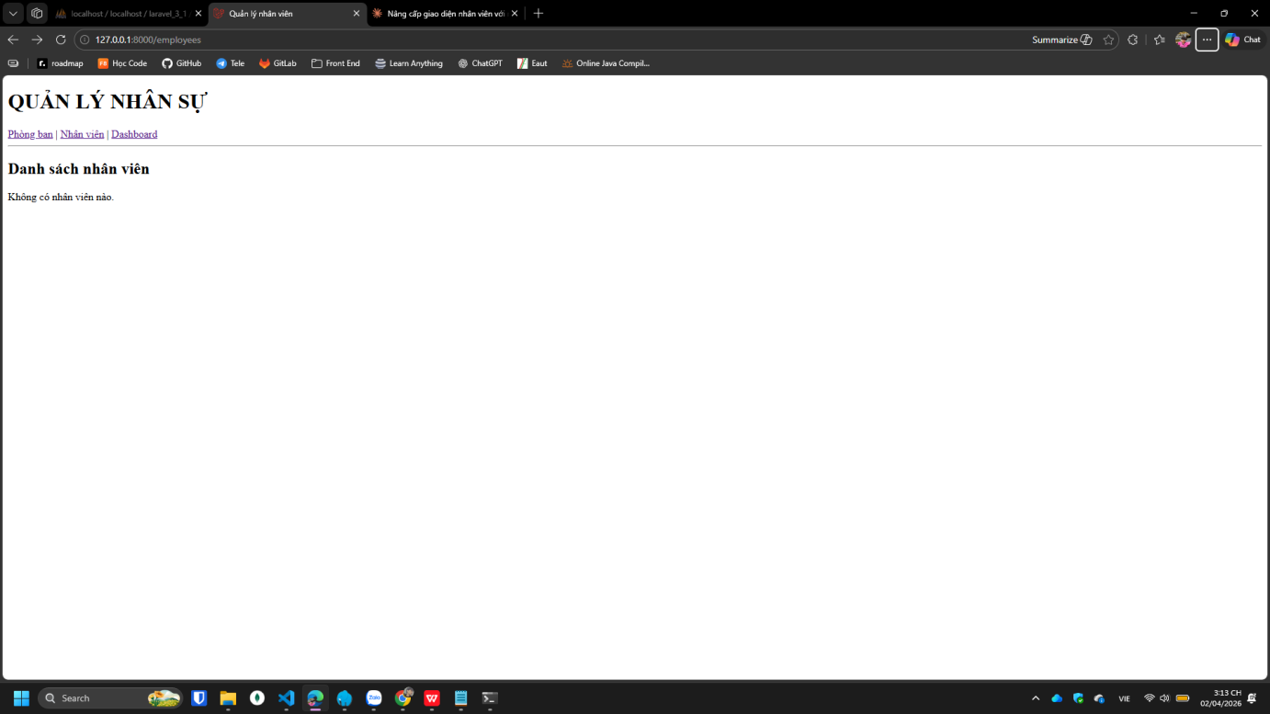

http://127.0.0.1:8000/employees/create
